**Image Processing of Damaged X-Ray Images**

**James Duxbury (bdzz75)**

## **Overview**

This report explores the use of image processing techniques on a dataset of 100 damaged, coloured x-ray lung images to enhance their visual quality and boost a classifier's accuracy, initially performing at 0.55.

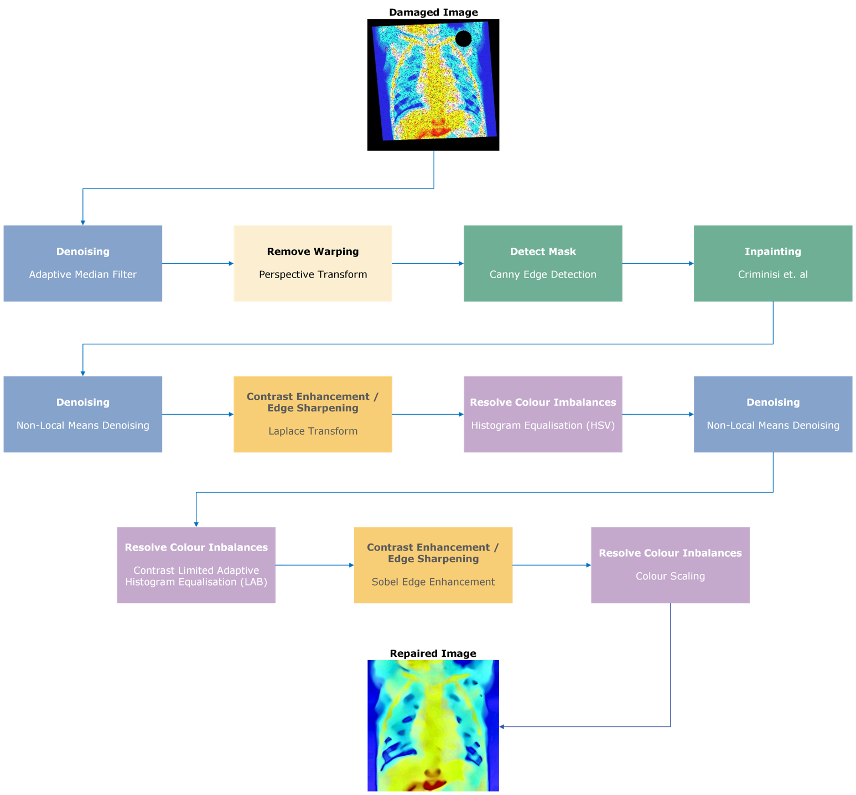The process followed is detailed in Fig.1.

Fig. 1 - Overview of the process completed to repair the damaged images.

## 2.0 Image Processing

### 2.1 Adaptive Median Filter (AMF)

Significant Gaussian and salt-and-pepper noise were evident in all images, posing a challenge in balancing noise reduction with detail preservation. While salt-and-pepper noise is commonly addressed using a median filter, this proved to cause excessive blurring.

To address this issue, a custom Adaptive Median Filter (AMF) was developed. Applied to each colour channel, this function updates a pixel's value only if it deviates by a predefined threshold from its neighbouring pixels. If the threshold is not met, the kernel size is incrementally increased by two, up to a maximum.

### A diagram of a medical scan Description automatically generated with medium confidenceAs seen in Fig.2, despite being less effective in eliminating salt-and-pepper noise, compared to MedianBlur(), AMF demonstrated superior preservation of image details. When integrated into the workflow, the overall image accuracy improved by 9% compared with MedianBlur().

Fig. 2 - Comparison between my adaptive median filter and OpenCV's MedianBlur()

### 2.2 Projective Transforms

All images in the dataset exhibited warping, affecting solely the image’s perspective. This was resolved by using a projective transform.

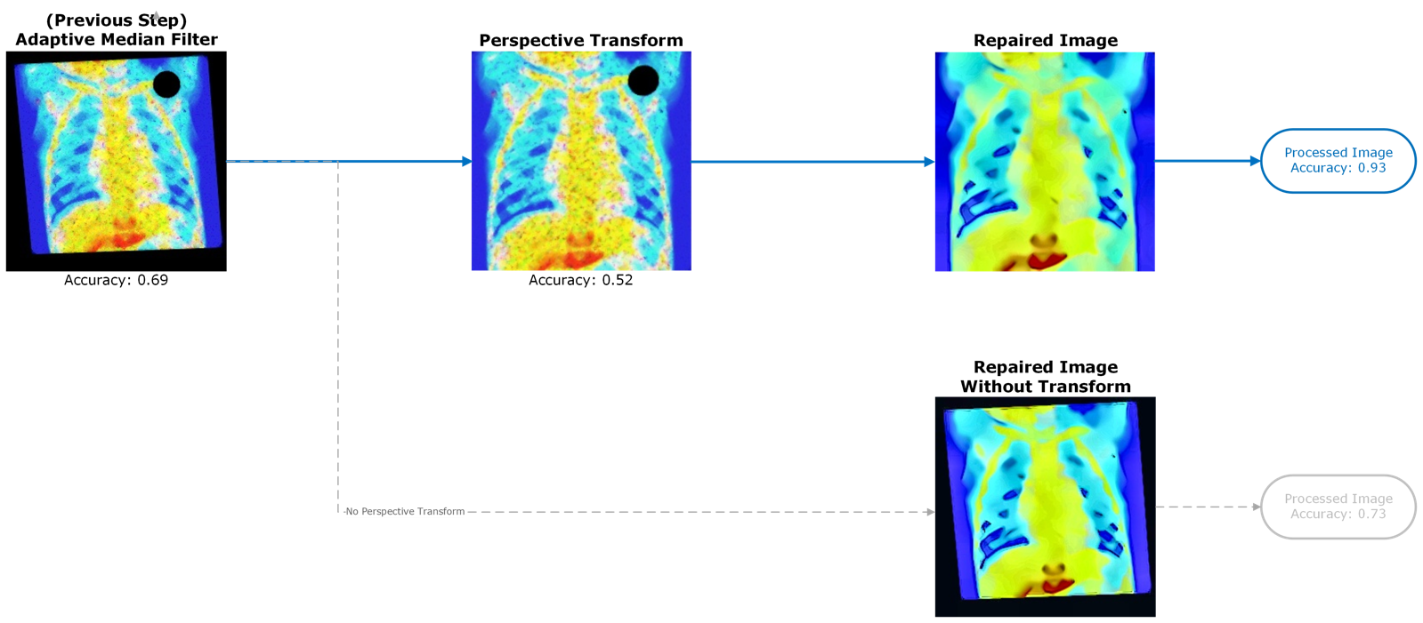

Fig. 3 - Analysis of Perspective Transform

Post application of AMF, the classifier achieved an accuracy of 0.69. However, upon application of the projective transform, the accuracy regressed to 0.52. Interestingly, refraining from employing the projective transform yielded an improved overall accuracy of 0.73, marking a 20% decrease compared to employing the transform.

It is noteworthy that the absence of the perspective transform not only influences the classifier accuracy but also impacts visual quality. Specifically, without the transform, the presence of black artifacts blending into the image edges introduces a perceptual ambiguity, potentially leading to vital information loss. Furthermore, in certain instances, the black borders assumed a blue hue, further complicating the interpretability of the images.

### 2.3 Canny Edge Detection

A systematic approach was employed to produce the mask for inpainting. Each image was converted to grayscale, to ensure the mask’s independence from colour channel values. The top-right quadrant of the image was selected as the region of interest (ROI) due to all masks falling within this area. This selection reduced any errors found from larger contours within the image, specifically from the base of the lung, affecting the produced mask.

Canny edge detection was subsequently applied to the identified region to identify areas with high gradient magnitudes, indicating edges. Employing high threshold values helped suppress noise and accentuate relevant edge information. The detected edges were transformed into contours, with the largest contour, assumed to encapsulate the missing region, selected for further analysis. A circular boundary slightly larger than the selected contour was delineated to ensure comprehensive coverage of the area requiring inpainting.

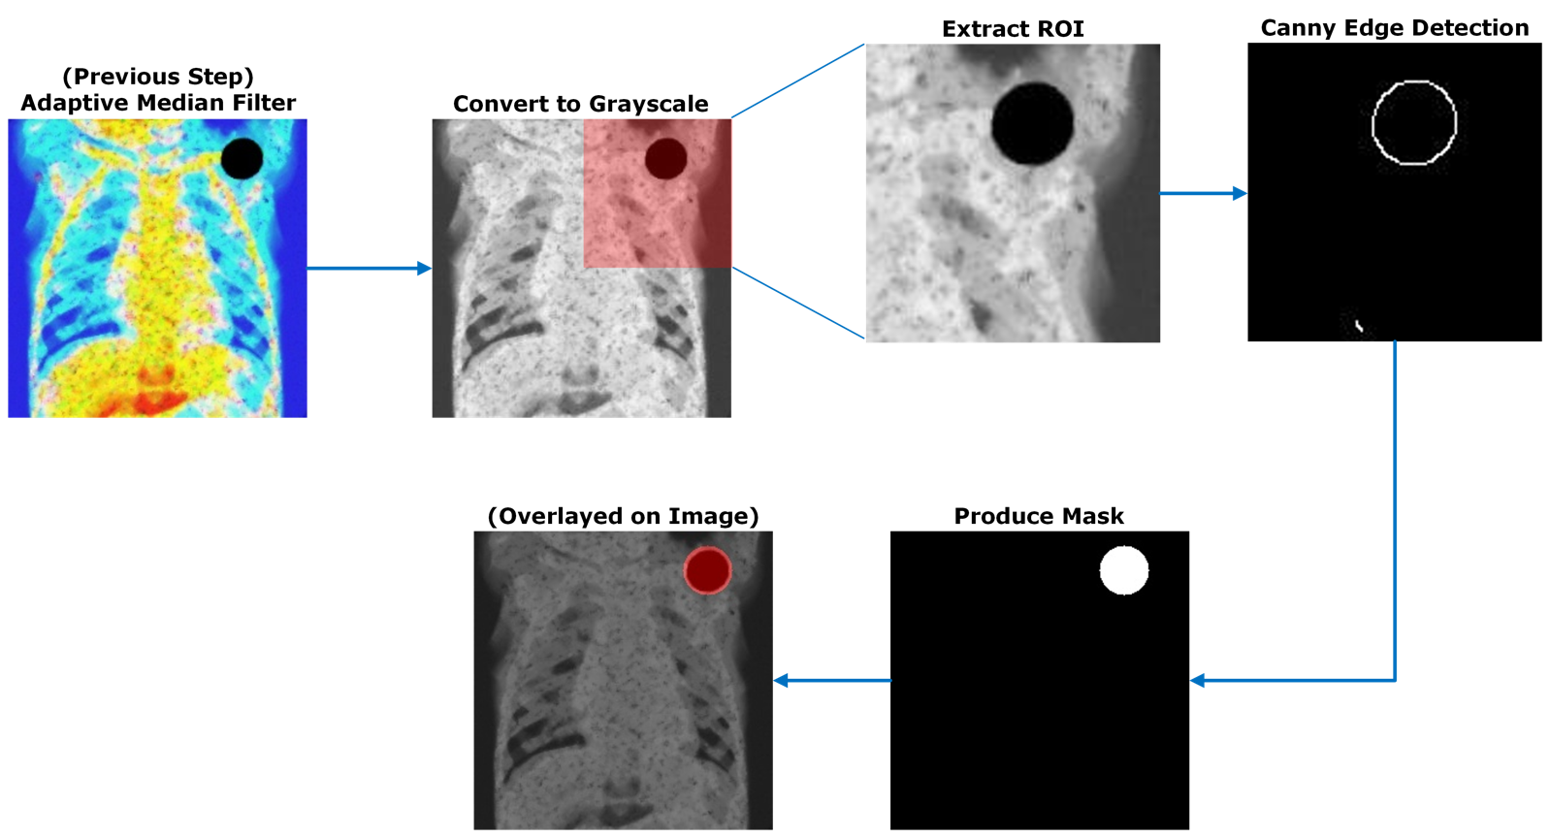

Fig. 4 – Diagram outlining the process of using Canny edge detection to produce masks for inpainting.

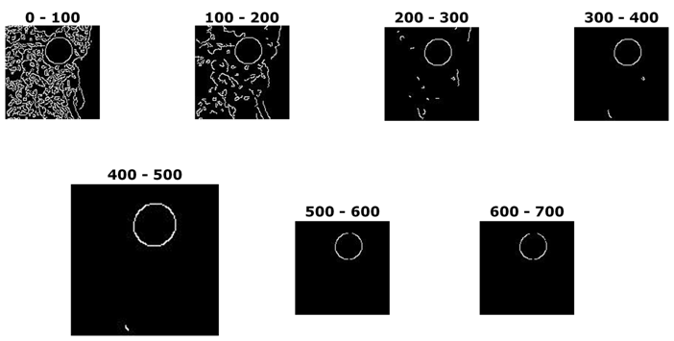The selection of thresholds for Canny edge detection was made to effectively mitigate noise while preserving the integrity of the region to the greatest extent possible.

Fig. 5 – Edges detected between different thresholds using Canny() on im001-healthy.jpg. As can be seen, 400-500 reduces noise just enough, without removing too much of the main circle, allowing for an accurate region to be drawn.

This method produced exemplary results.

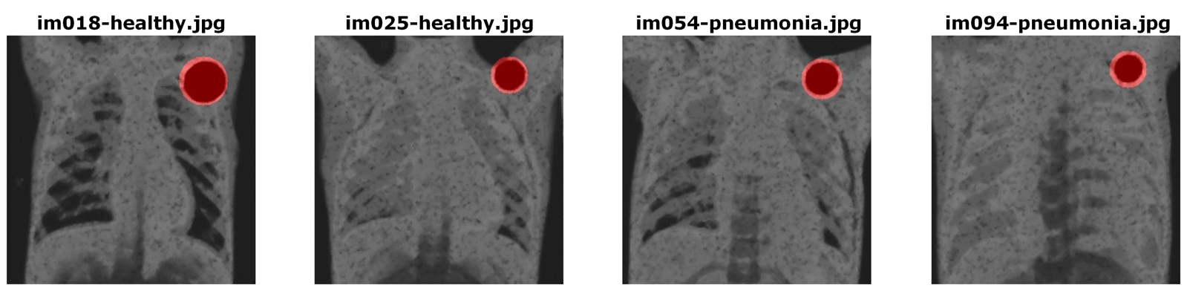

Fig. 6 – Overlaying the detected mask over greyscale images to show accuracy

### 2.4 Inpainting

Inpainting was achieved using a slightly adapted version of a python implementation [1] of the region filling algorithm proposed by Criminisi et. al. [2]. The algorithm uses exemplar-based image inpainting by using the isophote information of boundary pixels to extend linear structures. The algorithm also extends around the initial patch in a clockwise motion, improving linear structures compared to traditional concentric approaches.

Fig. 7 – Analysis of the use of Criminisi’s algorithm with that of OpenCV’s inbuilt method.

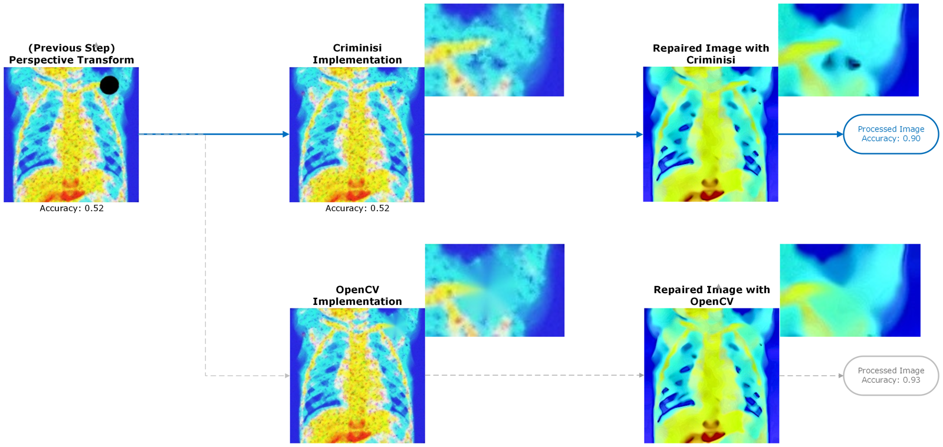

As can be seen in Fig.6, the application of Criminisi’s algorithm provide superior inpainting performance, compared to OpenCV’s inbuilt methods. The collarbone is plausibly extrapolated, and it becomes hard to detect that a missing region was present at all. OpenCV’s method is excessively blurry. Despite the remarkable increase in visual quality, Criminisi’s method achieved an intermediate accuracy of 0.52 (marking no improvement from the previous step), whereas OpenCV’s method produced an intermediate accuracy of 0.83. Final accuracy shows that my method achieved 0.9, but using OpenCV’s would have achieved 0.93.

**This process comes with a computational cost. On a MacBook Pro M1 with 8GB RAM, processing all images took approximately 2 hours and 15 minutes. Therefore, allocating at least 3 hours for testing is advisable, perhaps up to 5.**

### 2.5 Non-Local Means Denoising

Despite AMF removing substantial salt-and-pepper noise, significant noise remained. This was improved with a Non-Local Means (NLM) denoiser. NLM works by dividing the image into patches, comparing, and weighting their similarity. Noise is then removed from patches by replacing pixels with the weighted average of similar patches.

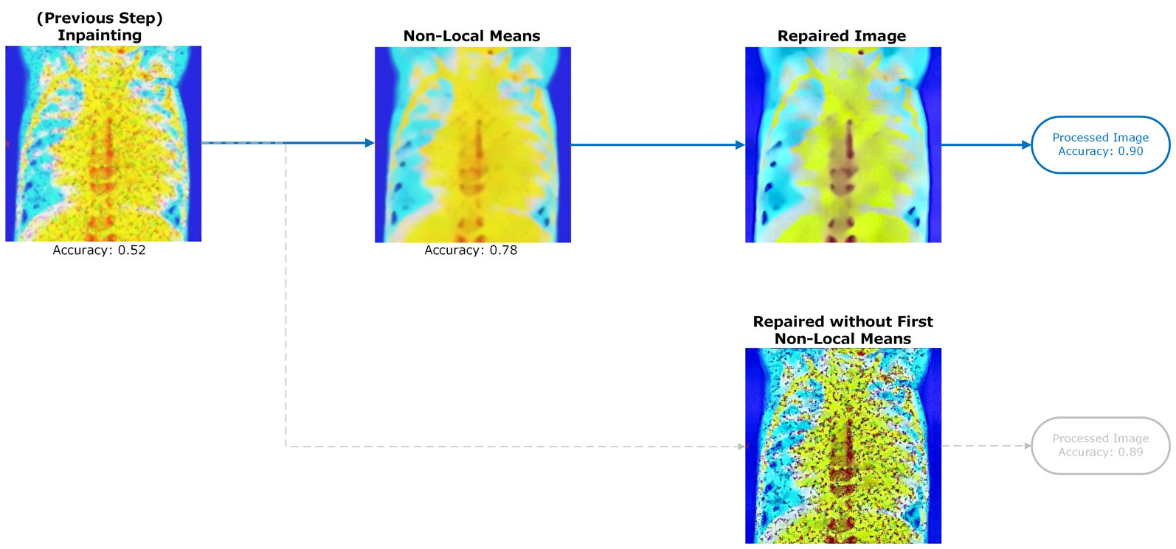

Fig. 8 – Analysis of the use of NLM on im051-pneumonia.jpg

As you can see from Fig.8, NLM effectively removed almost all noise, at the expense of a loss of clarity. Colours are more muted, and edges not well defined. However, the image is qualitatively improved. The final repaired image with the first NLM present is only 1% more accurate than without, however not including the first NLM leads to the remaining salt-and-pepper noise being amplified, losing any benefits of increased clarity.

### 2.6 Laplace Transform

Sharpness was regained by applying the Laplacian Operator on each image, and subtracting this from the image. As can be seen in Fig.9, this improved sharpness and colour depth, at the slight reintroduction of noise.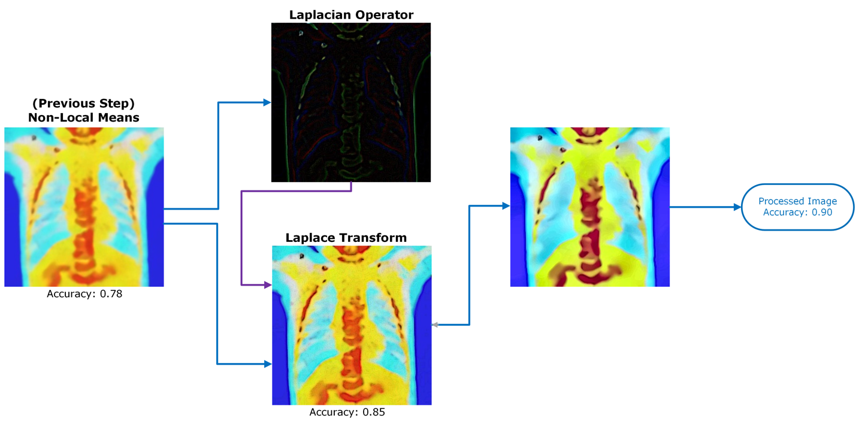

Fig. 9 – Overview of Laplace Transformation on im028-healthy.jpg

2.7 Histogram Equalisation in the YCrCb Colour Space

The damaged images appear to have a colour distribution not matching those of the reference images. Also, some colour channels appear brighter than others. My first step to improve this is through Histogram Equalisation. I completed Histogram Equalisation in the HSV colour space, specifically the Variance channel, as this was able to update the contrast and brightness of an image, without affecting individual colour channels.

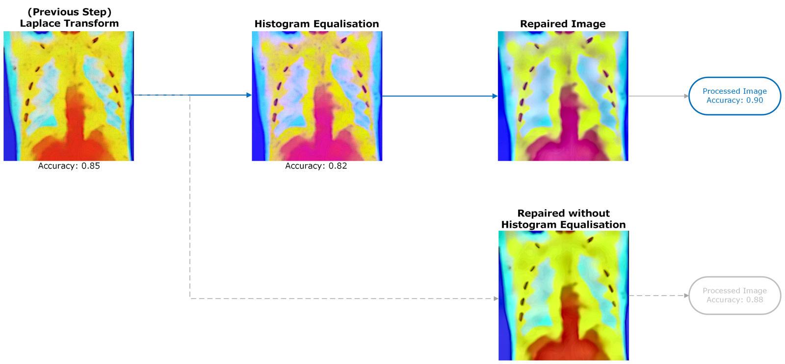

Fig. 10 – Application of Histogram Equalisation on im007-healthy.jpg

### 2.8 Reapplication of Non-Local Means Denoising

Following the Laplace transform and histogram equalisation, small amounts of gaussian noise were reintroduced (or enhanced), which I removed by reapplying NLM. This shows the versatility for NLM to work on multiple types of noise, compared to more traditional methods. Noise was massively reduced, compared to images without the second reapplication, despite classifier accuracy being 1% lower.

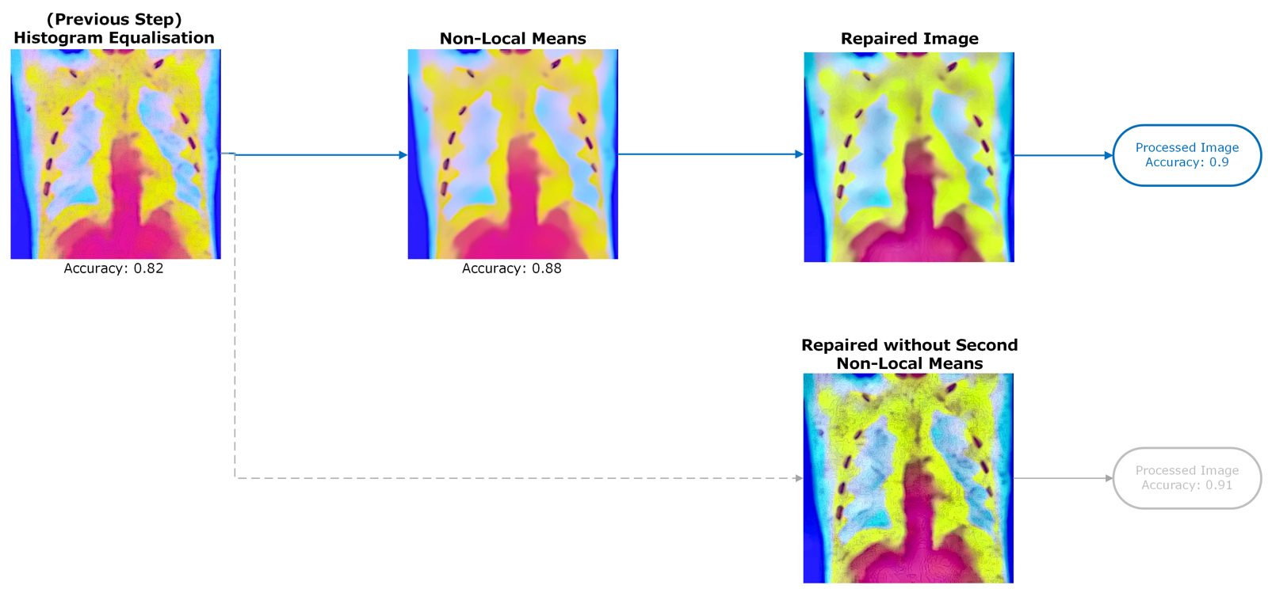

Fig. 11 – Second application of NLM on im007-healthy.jpg

### 2.9 Contrast Limited Adaptive Histogram Equalisation in the LAB Colour Space

### To enhance the image's contrast, I utilised CLAHE in the LAB colour space. CLAHE partitions the image into tiles and equalizes the histogram of each tile to expand its dynamic range while preventing excessive enhancement through contrast limiting. Opting for the LAB colour space allowed me to exclusively target the 'Lightness' channel, avoiding unintended alterations to colour information. This approach facilitated a more uniform colour distribution, a topic I'll discuss later.

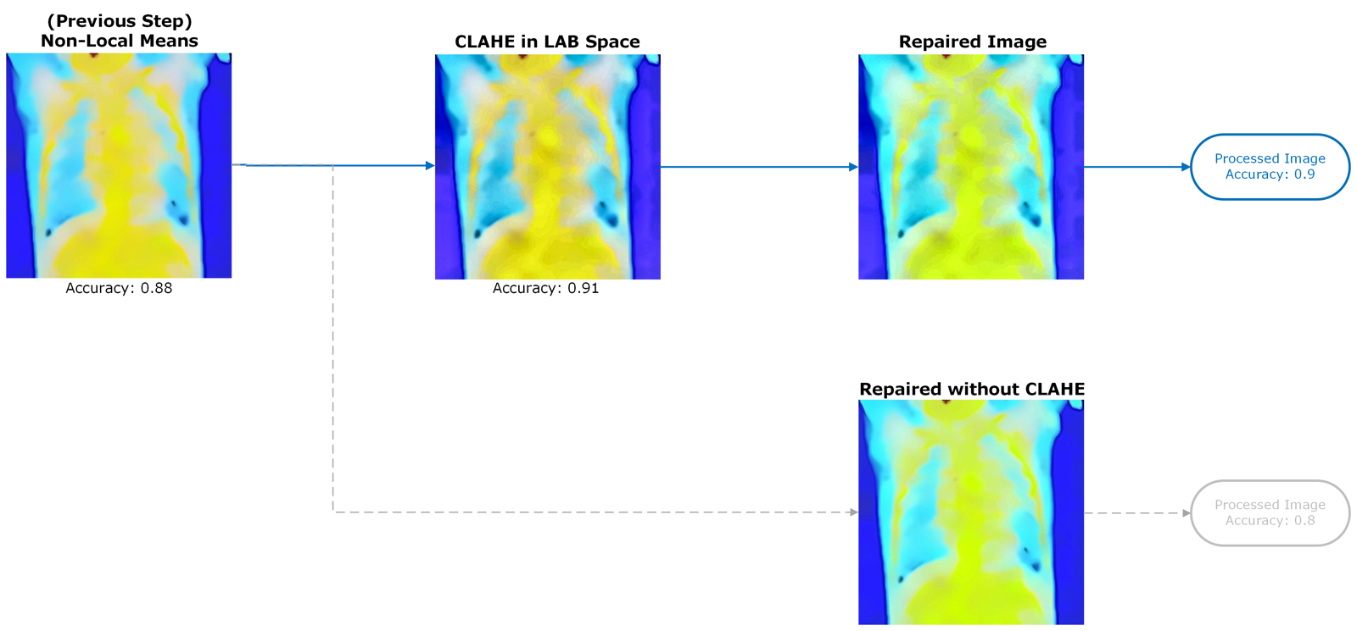

Fig. 12 – Application of CLAHE on im011-healthy.jpg

### As can be seen in Fig.12, the repaired image has more dark spots than the repaired image without CLAHE, but performs 10% better.

### 2.10 Sobel Edge Enhancement

I wished to further enhance the edges that were blurred as a result of the second application of NLM. To achieve this, I used Sobel edge enhancement, which calculated gradients in the horizontal and vertical directions. These gradients were combined to compute the magnitude and direction of edges, which when combined with the original image, improved sharpness.

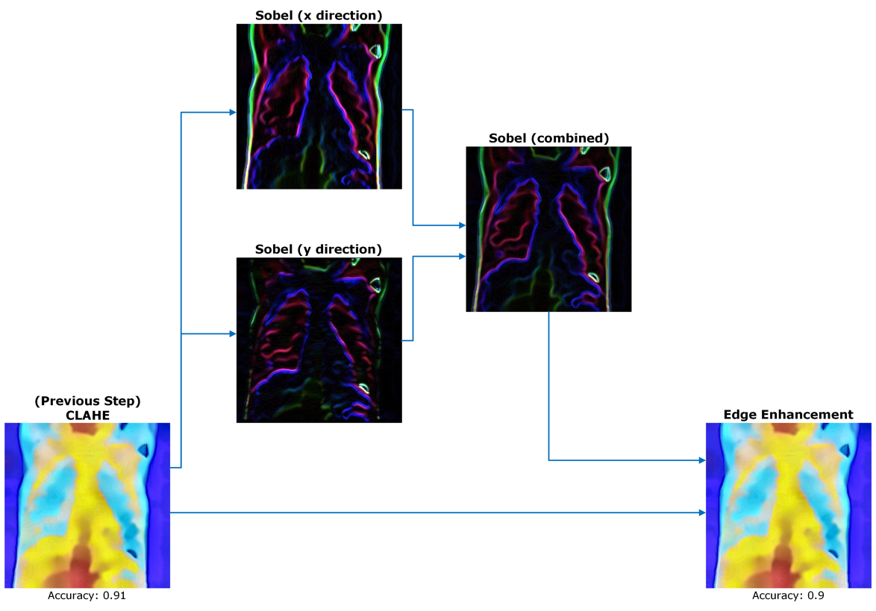

Fig. 13 – Sobel edge enhancement applied on im099-pneumonia.jpg

### 2.11 Colour Scaling

Colour remained a final issue I wished to resolve; despite colour imbalances being resolved previously, colour distributions of reference did not match my repaired images. Green was a lot more apparent in the reference images. Also, a lot of ‘healthy’ x-rays had patches of pink or white, which misguided the classifier. To resolve this, I scaled the red channel by a factor of 0.9, and green by a factor of 1.1, improving the overall visual appearance of the image to match those of the references.

Fig. 14 – Application of colour scaling on im001-healthy.jpg

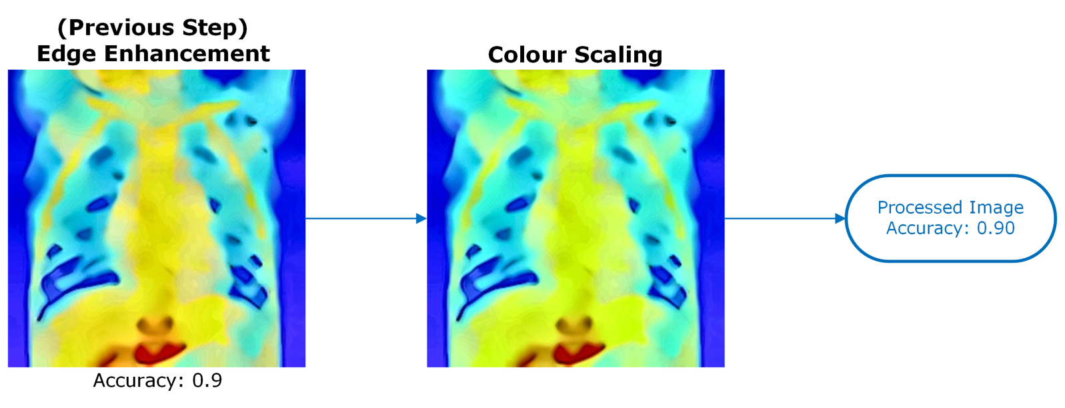

## 3.0 Analysis

I was able to achieve an accuracy of 0.90 with my methods, 0.93 using OpenCV’s inpaint() method. I chose to proceed with the Criminisi inpainting, recognising the trade-off between visual quality and classifier accuracy – I preferred to sacrifice three percent for more accurate inpainting.

### 3.1 Analysis of Classifier Accuracy

The below figure shows the classifier accuracy across each intermediate step.

Fig. 15 – Analysis of classifier performance for each intermediate processing step.

### The proposed methods provide an improvement of 35% compared to the damaged images. Performance regressed the most during the projective transform, however moving this to a later stage would cause bleeding of the edges, and loss of image quality.

### 3.2 Analysis of Image Quality

Fig. 16 – Comparison of damaged and repaired images, along with a reference image provided beforehand.

The proposed process has significantly improved the visual quality of the images. Warping and noise have successfully been removed, positive measures have been made to improve colour and contrast imbalances, and the implementation of Criminisi’s algorithm has made realistic inpainting of the missing regions. Further work could be made to have the colours match the reference images better, but I feel the proposed method has been successful.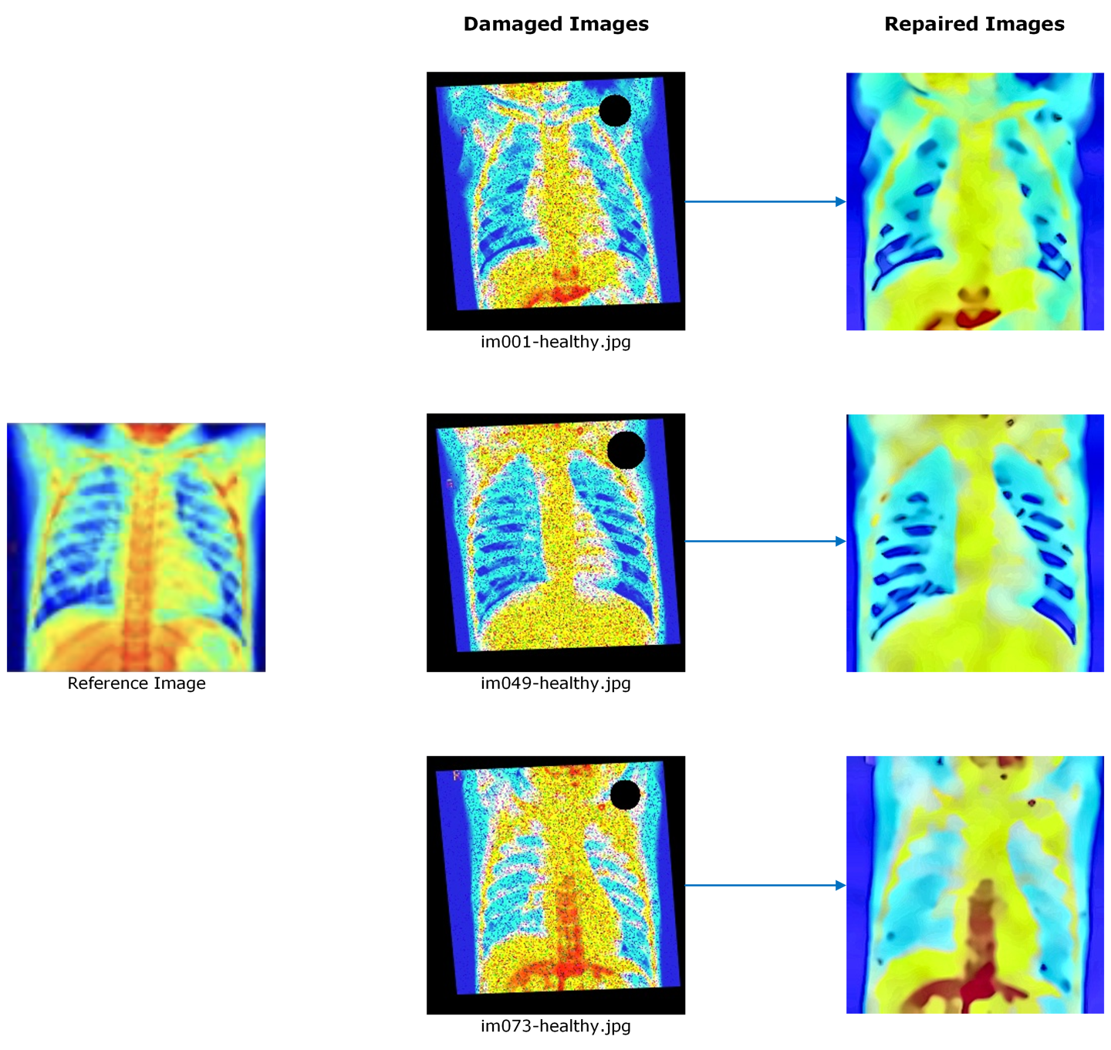

# Bibliography

|  |  |
| --- | --- |
| [1] | N. Nahar, “GitHub Repository,” 11 12 2021. [Online]. Available: https://github.com/NazminJuli/Criminisi-Inpainting. |
| [2] | A. Criminisi, P. Pérez and K. Toyama, “Region Filling and Object Removal by Exemplar-Based Image Inpainting,” *IEEE TRANSACTIONS ON IMAGE PROCESSING,* vol. 13, no. 9, 2004. |